Chapter 1:Introduction

1.1 Introduction
Life+Link System is a web-based healthcare and organ donation management platform developed using Python, Streamlit, and SQLite database. The main objective of the system is to simplify organ donation management, hospital communication, emergency organ requests, and inventory management through a centralized digital platform.
The system provides separate modules for users, hospitals, organ banks, and administrators. Users can register as organ donors and manage their profiles. Hospitals can send organ requests, manage emergency cases, and communicate with organ banks. Organ banks can maintain donor records and organ inventory, while administrators can monitor the entire system using analytics dashboards.
Traditional organ donation systems mainly depend on manual paperwork and offline communication, which creates delays during emergency situations. The Life+Link System helps in reducing manual work and improving healthcare communication through automation and centralized management.
The project is developed using Streamlit for frontend interface development and SQLite database for storing all healthcare records. The application also includes blood group compatibility matching, certificate generation, sound notifications, and dashboard analytics.
1.2 Motivation
The motivation behind developing the Life+Link System comes from the difficulties faced by hospitals and healthcare organizations during emergency organ request handling. In many healthcare systems, donor records and emergency communication are maintained manually, which increases complexity and delays response time.
Organ donation requires proper communication between hospitals, organ banks, and donors. However, traditional systems often lack centralized management and real-time inventory tracking. Patients may face delays in finding suitable organ donors because of inefficient record handling and communication systems.
This project aims to provide a digital solution that simplifies organ donation management and improves healthcare communication. The system provides donor matching, centralized inventory management, and emergency request handling through an organized web platform.

1.3 Purpose
The purpose of the Life+Link System is to provide an efficient healthcare management platform for organ donation and emergency request management. The system helps users register as donors while allowing hospitals and organ banks to manage requests and inventory digitally.
The platform provides secure authentication and centralized database management for maintaining donor records, hospital requests, emergency cases, and inventory details. The project also aims to reduce paperwork and improve communication between hospitals and organ banks.
Another purpose of the project is to provide analytics dashboards for administrators and support blood group compatibility matching during emergency situations.
1.4 Objectives
The objectives of the Life+Link System are:
- To develop a centralized healthcare management platform.
- To provide role-based login functionality.
- To manage organ donor registration digitally.
- To handle emergency organ requests efficiently.
- To maintain organ inventory records.
- To provide blood group compatibility matching.
- To generate dashboard analytics for monitoring.
- To reduce manual paperwork and management complexity.

Chapter 2 Literature Survey

2.1 Existing System
Most healthcare organizations currently use manual methods for managing organ donation records and emergency communication. Hospitals maintain donor and patient records separately, which creates difficulties in data management and emergency coordination.
Existing healthcare systems usually lack centralized inventory management and donor matching functionality. Emergency organ requests require quick communication between hospitals and organ banks, but traditional systems often fail to provide fast response management.
2.1.1 Elaborate on Existing System Applications
Many hospitals use spreadsheets, registers, and basic healthcare software for maintaining donor and patient records. Some healthcare organizations use standalone management applications for inventory and patient details.
A few organ donation organizations provide donor registration through websites, but these systems generally do not include advanced features like emergency request handling, donor matching, analytics dashboards, and centralized communication.
Most existing systems focus only on patient management and do not provide complete organ donation and healthcare inventory management solutions.
2.1.2 Limitations or Challenges in Existing System
The existing systems have several limitations:
- Manual record management increases complexity.
- Lack of centralized communication between hospitals and banks.
- Delayed emergency request handling.
- Difficult inventory management.
- No proper donor matching system.
- Limited analytics and monitoring support.
- Increased chances of data redundancy and errors.

2.2 Problem Statement
Hospitals and healthcare organizations face difficulties in managing organ donor records and emergency organ requests efficiently. Traditional systems depend on manual communication and paperwork, which reduces transparency and delays emergency healthcare services.
Organ banks also face challenges in maintaining donor inventory and matching donors with recipients quickly. Existing systems do not provide centralized donor matching, analytics dashboards, and emergency management support.
The Life+Link System aims to solve these problems by providing a centralized web-based healthcare platform with donor management, inventory tracking, emergency request handling, and analytics features.
2.3 Feasibility Study
Technical Feasibility
The project is technically feasible because it uses Python, Streamlit, and SQLite, which are lightweight and easy-to-use technologies. The required software tools are open-source and can run on standard computer systems.
Economic Feasibility
The project is economically feasible because it uses free and open-source technologies. No expensive hardware or commercial software is required.The system is user-friendly and easy to operate for users, hospitals, organ banks, and administrators. The platform provides centralized healthcare management with secure authentication and dashboard support.
Chapter 3 Project Scope and Requirement Analysis

3.1 Requirement Gathering and Analysis
Requirement gathering and analysis is an important phase in the development of the Life+Link System. The requirements were identified by studying the problems faced in traditional healthcare and organ donation management systems and understanding the workflow needed to achieve the objectives of the project.
1. To develop a centralized healthcare management platform
The analysis identified the need for a centralized system where users, hospitals, organ banks, and administrators can work together through a single platform. In the Life+Link System, centralized healthcare management is achieved by integrating all modules into one application connected with a common SQLite database.
The workflow begins when users, hospitals, organ banks, or administrators login into the system. All healthcare records such as donor details, organ requests, inventory data, emergency cases, and analytics are stored and managed centrally. This centralized workflow improves communication, data management, and emergency healthcare coordination.
2. To provide role-based login functionality
The requirement analysis identified the need for secure role-based access for different users of the system. The Life+Link System includes separate login functionality for Users, Hospitals, Organ Banks, and Administrators.
After authentication, the system redirects users to their respective dashboards according to their role. Users can manage donor profiles, hospitals can handle emergency requests, organ banks can manage inventory, and administrators can monitor analytics and reports. This workflow improves system security and organized healthcare management.

3. To manage organ donor registration digitally
The analysis showed that manual donor registration creates difficulties in maintaining records and accessing donor information quickly during emergencies. Therefore, the system includes a digital donor registration workflow.
Users enter personal details, blood group information, contact details, and donation preferences through online forms. The system validates the information and stores donor records securely in the database. Hospitals and organ banks can access donor information whenever required.
4. To handle emergency organ requests efficiently
The requirement analysis identified the need for a fast emergency request management system for hospitals. In the Life+Link System, hospitals can create emergency organ requests through the Hospital Dashboard.
The workflow includes request submission, inventory checking, donor matching, and request status updates. Organ banks receive emergency requests and process them according to organ availability. This workflow improves emergency healthcare response and reduces delays in organ allocation.
5. To maintain organ inventory records
The analysis identified that organ banks require proper inventory management to maintain organ availability records efficiently. The Organ Bank Module allows organ banks to add, update, and monitor inventory information digitally.
The workflow includes organ record entry, inventory updates, availability monitoring, and request processing. The system stores all inventory records centrally in the database for quick access and management.

6. To provide blood group compatibility matching
The requirement analysis identified the need for donor-recipient matching functionality during emergency situations. The system includes a donor matching workflow based on blood group compatibility.
Hospitals enter recipient blood group details and organ requirements. The system compares donor blood groups with recipient requirements and displays compatible donor records. This workflow improves the speed and accuracy of donor identification.
7. To generate dashboard analytics for monitoring
The analysis showed that administrators require monitoring and reporting functionalities for healthcare management. Therefore, the system includes analytics dashboards and graphical reports.
The workflow collects donor statistics, emergency request records, hospital activities, and inventory data from the database and displays them through charts and reports. This helps administrators monitor overall healthcare operations efficiently.
8. To reduce manual paperwork and management complexity
The requirement analysis identified that traditional healthcare systems depend heavily on paperwork and manual communication. The Life+Link System automates donor registration, inventory handling, emergency request processing, and analytics generation digitally.
The workflow reduces manual record handling by storing all healthcare information in a centralized database. This improves efficiency, reduces management complexity, and minimizes data handling errors.

3.2 Software Requirements
- Frontend Framework: Streamlit
Used for developing the user interface, dashboards, forms, and interactive web pages of the Life+Link System.
- Backend Language: Python
Used for implementing backend logic, authentication, database operations, donor matching, and healthcare management functionalities.
- Database: SQLite3
Used for storing user records, hospital details, organ donor information, emergency requests, inventory records, and analytics data.
- IDE/Editor: Visual Studio Code
Used for writing, editing, debugging, and executing Python code.
- Operating System: Windows
The application is designed to run on Windows operating systems.
- Python Libraries Used:
• Streamlit
• sqlite3
• pandas
• hashlib
• os
• datetime
- Browser: Google Chrome
Used for running and testing the Streamlit web application.
3.3 Hardware Requirements
The Life+Link System can be used by users on both mobile phones and computers, while hospitals, organ banks, and administrators mainly use desktop or laptop systems for managing healthcare operations and dashboards. The hardware requirements for smooth execution of the application are as follows:
- Processor: Dual Core Processor or Higher
Required for smooth execution of the application and healthcare management operations.
- RAM: Minimum 4 GB
Required for frontend, backend, and database operations efficiently.
- Storage: Minimum 5 GB Free Space
Used for storing project files, healthcare records, donor information, and inventory data.
- Keyboard and Mouse:
Required for data entry, navigation, and managing dashboards on desktop or laptop systems.
- Monitor/Display Screen:
Required for displaying application dashboards, reports, forms, and healthcare management interfaces.
- Power Supply:
Continuous power supply is necessary for uninterrupted system operation.
- Internet Connection:
Required for accessing the application, downloading dependencies, and maintaining communication between users, hospitals, and organ banks.
3.4 Function requirements
a) User Defined Function
- User Authentication Function
The system should allow users, hospitals, banks, and administrators to register and login securely.
- Role Management Function
The system should differentiate between User, Hospital, Organ Bank, and Admin roles.
- Donor Registration Function
Users should be able to register as organ donors and manage donor details digitally.
- Hospital Request Management Function
Hospitals should be able to create and manage organ requests and emergency cases.
- Inventory Management Function
Organ banks should be able to maintain organ inventory and availability records.
- Blood Group Matching Function
The system should match donors and recipients based on blood group compatibility.
- Emergency Request Function
Hospitals should be able to send emergency organ requests quickly and efficiently.
- Analytics Dashboard Function
The system should provide analytics dashboards for monitoring healthcare activities and inventory records.
- Certificate Generation Function
The system should generate digital certificates for registered organ donors.
- Notification Function
The system should provide sound notifications and alerts for important actions and emergency activities.
- Database Management Function
The system should securely store and retrieve donor records, inventory data, and request information using SQLite database.

b) System Functions
- Session Management Function
The system should securely maintain login sessions for all users and administrators.
- Database Management Function
The system should securely store and retrieve donor records, inventory data, and request information using SQLite database.
- Authentication Verification Function
The system should validate login credentials and provide secure access control.
- Data Processing Function
The system should process donor matching, emergency requests, and inventory operations efficiently.
- Analytics Processing Function
The system should generate reports, charts, and analytics dashboards for monitoring healthcare activities.
3.5 Non-Functional Requirements
- User-Friendly Interface
The system should provide a simple and easy-to-use interface for all users.
- Performance
The application should respond quickly during donor registration, request handling, and dashboard operations.
- Security
User data, donor records, and login credentials should be stored securely.
- Reliability
The system should perform healthcare management operations without major errors or failures.
- Maintainability
The project should be easy to maintain, update, and improve in the future.
- Scalability
The system should support future enhancements such as cloud integration and mobile application support.
- Responsiveness
The application interface should work properly on different screen sizes and devices.
- Availability
The system should be available whenever hospitals, users, or administrators access it.
- Database Integrity
The system should maintain accurate and consistent healthcare records in the database.

Chapter 4 :Project Design and Modeling Details

4.1 Software Requirement Specification (SRS):
1. User Authentication Function
The User Authentication Function is responsible for secure registration and login for Users, Hospitals, Organ Banks, and Administrators.
- Input Required: Username, Email, Password, Role
- Process:
The system validates login credentials and checks database records for authentication. After successful verification, users are redirected to their respective dashboards.
- Database Tables Used:
• Users Table
• Hospitals Table
• Admin Table
- Software Components Used:
• Streamlit Forms
• Python Authentication Logic
• SQLite Database Connectivity
2. Role Management Function
The Role Management Function differentiates between User, Hospital, Organ Bank, and Admin roles within the system.
- Input Required: Selected Role during Login
- Process:
The system identifies the role and provides access to the appropriate dashboard and functionalities.
- Database Tables Used:
• Users Table
• Hospitals Table
• Admin Table
- Software Components Used:
• Session Management
• Dashboard Routing
• Streamlit Navigation Components
3. Donor Registration Function
The Donor Registration Function allows users to register as organ donors digitally.
- Input Required:
Name, Blood Group, Contact Number, Address, Organ Details
- Process:
The system validates donor details and stores donor information securely in the database.
- Database Tables Used:
• Users Table
• Donor Requests Table
- Software Components Used:
• Streamlit Forms
• SQLite Insert Queries
• Python Validation Functions
4. Hospital Request Management Function
The Hospital Request Management Function allows hospitals to create and manage organ requests and emergency cases.
- Input Required:
Patient Details, Organ Required, Blood Group, Emergency Status
- Process:
Hospitals submit requests which are stored and processed through the database system.
- Database Tables Used:
• Hospitals Table
• Donor Requests Table
• Emergency Requests Table
- Software Components Used:
• Request Processing Logic
• Streamlit Dashboard
• SQLite Queries
5. Inventory Management Function
The Inventory Management Function allows organ banks to maintain organ inventory and availability records.
- Input Required:
Organ Name, Quantity, Donor Details, Availability Status
- Process:
Organ banks add and update inventory records in the database.
- Database Tables Used:
• Inventory Table
- Software Components Used:
• Streamlit Inventory Forms
• Database Update Queries
• Python Inventory Functions
6. Blood Group Matching Function
The Blood Group Matching Function matches donors and recipients based on blood group compatibility.
- Input Required:
Recipient Blood Group, Organ Required
- Process:
The system compares recipient blood group with donor records stored in the database and displays matching donors.
- Database Tables Used:
• Users Table
• Donor Requests Table
- Software Components Used:
• Python Matching Algorithms
• SQLite Search Queries
• Streamlit Result Display

7. Emergency Request Function
The Emergency Request Function allows hospitals to send emergency organ requests quickly and efficiently.
- Input Required:
Emergency Organ Requirement, Blood Group, Hospital Details
- Process:
Emergency requests are processed and verified with donor and inventory records.
- Database Tables Used:
• Emergency Requests Table
• Inventory Table
- Software Components Used:
• Emergency Request Processing
• Database Verification
• Notification Handling
8. Analytics Dashboard Function
The Analytics Dashboard Function provides healthcare monitoring and reporting functionalities for administrators.
- Input Required:
Healthcare Data, Donor Records, Inventory Statistics
- Process:
The system collects data from database tables and generates charts and reports.
- Database Tables Used:
• Users Table
• Inventory Table
• Emergency Requests Table
- Software Components Used:
• Pandas DataFrames
• Matplotlib Charts
• Streamlit Dashboard Components
9. Certificate Generation Function
The Certificate Generation Function generates digital donor certificates for registered users.
- Input Required:
Donor Name, Registration Details, Blood Group
- Process:
The system verifies donor information and generates digital certificates automatically.
- Database Tables Used:
• Users Table
- Software Components Used:
• Python Certificate Generation Logic
• PIL Library
• Streamlit Download Functionality
10. Notification Function
The Notification Function provides sound alerts and notifications for important system activities.
- Input Required:
Login Activity, Request Submission, Emergency Updates
- Process:
The system generates alerts and notifications based on user activities and healthcare events.
- Database Tables Used:
• Emergency Requests Table
• Inventory Table
- Software Components Used:
• Python Notification Functions
• Streamlit Alerts
• Audio Notification Components

11. Database Management Function
The Database Management Function securely stores and retrieves healthcare records using SQLite database.
- Input Required:
User Data, Donor Records, Inventory Details, Emergency Requests
- Process:
The system performs insert, update, delete, and retrieval operations for all healthcare records.
- Database Tables Used:
• Users Table
• Hospitals Table
• Inventory Table
• Donor Requests Table
• Emergency Requests Table
• Admin Table
- Software Components Used:
• SQLite Database
• Python Database Functions
• SQL Queries

4.2 System Architecture
The Life+Link System is designed as a centralized healthcare and organ donation management platform where Users, Hospitals, Organ Banks, and Administrators interact through separate modules and dashboards. The system workflow is designed according to the functionalities implemented in the project.
The first screen of the project contains the Select Role section where users can choose their role such as User, Hospital, Organ Bank, or Admin. This functionality helps the system provide role-based operations and secure access for different users.
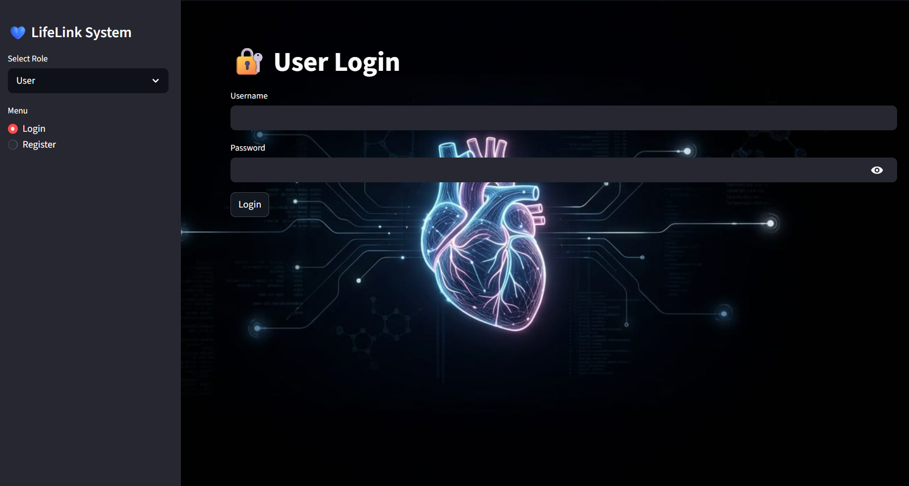
The system also contains a Menu Section which provides Login and Register options. These functionalities help users access the system and perform healthcare management operations digitally.

- Username Field
The Username field is used to identify users uniquely within the system during login and registration operations.
- Purpose:
To provide secure user identification.
- Features Provided:
• Unique user access
• Role-based authentication
• Secure login functionality
- Validation Constraints:
• Username should not be empty
• Duplicate usernames are restricted
• Invalid characters are not accepted
- Password Field
The Password field is used for secure authentication and account protection within the system.
- Purpose:
To prevent unauthorized access and maintain system security.
- Features Provided:
• Secure authentication
• Password verification
• Login protection
- Validation Constraints:
• Password should not be empty
• Invalid passwords display error messages
• Authentication is required before dashboard access
- Login Functionality
The Login functionality allows registered users to access the system securely according to their selected role.
- Workflow:
  - User selects role
  - User enters username and password
  - System validates credentials
  - User is redirected to the respective dashboard
- Features Provided:
• Secure login authentication
• Role-based dashboard access
• Session management
• Error handling for invalid login
- Register Functionality
The Register functionality allows new users to create accounts within the Life+Link System.
- Workflow:
  - User selects register option
  - User enters personal details
  - System validates information
  - Account is created successfully
- Features Provided:
• Digital donor registration
• Secure user account creation
• User profile management
• Healthcare platform accessibility
- User Dashboard
The User Dashboard provides functionalities such as:
• Organ donor registration
• Profile management
• Certificate generation
• Request tracking
The dashboard helps users manage donor-related activities efficiently.
- Hospital Dashboard
The Hospital Dashboard provides functionalities such as:
• Emergency organ request handling
• Patient management
• Donor matching
• Request monitoring
This dashboard improves hospital communication and emergency healthcare operations.
- Organ Bank Dashboard
The Organ Bank Dashboard provides functionalities such as:
• Organ inventory management
• Donor availability monitoring
• Organ record updates
• Emergency request processing
This module helps maintain healthcare resources efficiently.

- Admin Dashboard
The Admin Dashboard provides functionalities such as:
• Analytics monitoring
• Healthcare activity reports
• User management
• System monitoring
The administrator can monitor overall healthcare operations through graphical dashboards and reports.
- Notification System
The system provides sound notifications and alerts for important healthcare activities and emergency actions.
- Features Provided:
• Login success alerts
• Emergency request notifications
• Error notifications
• Inventory update alerts

4.3 System Modeling and Design
The Life+Link System is designed using a modular and centralized healthcare management approach. The system modeling defines how users, hospitals, organ banks, and administrators interact with the application and how data flows between different modules and the database.
The system begins with user authentication, where users select their role and login securely into the application. After successful authentication, users are redirected to their respective dashboards based on their roles.
The User Module allows organ donor registration, profile management, and request tracking functionalities. The Hospital Module handles patient records, emergency organ requests, and donor matching processes. The Organ Bank Module manages organ inventory, donor availability, and emergency request processing. The Admin Module monitors the complete system using analytics dashboards and reports.
The Donor Matching Module processes blood group compatibility and identifies suitable donors for hospitals during emergency situations. The Notification Module generates alerts and sound notifications for important activities such as successful login, request submission, and emergency actions.
The data flow of the system includes user input, request processing, database storage, donor matching, inventory verification, and dashboard visualization. SQLite database stores all healthcare records securely and provides efficient retrieval of donor information, inventory details, and emergency requests.
The system modeling and design improve communication between modules and ensure smooth healthcare management operations through centralized database connectivity and secure data handling.

4.4 Data Structures used
The Life+Link System uses different data structures for storing, managing, and processing healthcare records efficiently. These data structures help in organizing donor information, hospital records, inventory details, emergency requests, and analytics data systematically.
1. Lists
Lists are used for storing collections of donor records, hospital requests, inventory details, and analytics information temporarily during program execution. Lists help in managing multiple records dynamically and allow easy insertion and retrieval of healthcare data.
2. Dictionaries
Dictionaries are used for storing user details, donor information, hospital data, and inventory records in key-value pair format. This structure provides fast data access and improves data management efficiency within the system.
3. SQLite Database Tables
SQLite database tables are used for permanent storage of healthcare records such as users, hospitals, organ requests, inventory details, emergency requests, and administrator data. Database tables help maintain data consistency, security, and structured storage.
4. Pandas DataFrames
Pandas DataFrames are used for analytics dashboard generation, healthcare statistics, and report visualization. DataFrames help in organizing tabular data efficiently and support chart generation for administrators.
5. Strings
Strings are used for handling usernames, passwords, blood groups, organ names, addresses, emergency status messages, and notification messages throughout the application.
6. Integer and Float Variables
Integer and float data types are used for storing quantities, IDs, counts, analytics values, and inventory statistics within the system.
The combination of these data structures improves system performance, data organization, analytics processing, and efficient healthcare management operations.

Chapter 5: Implementation

5.1 Algorithms
1. User Authentication Algorithm
Algorithm Information
The User Authentication Algorithm is used only for login and access control in the Life+Link System. This functionality is limited to verifying the entered username and password for Users, Hospitals, Organ Banks, and Admins.
When the user enters login details, the system checks whether the username and password already exist in the respective database table. If the entered credentials match the stored records, the user gets access to the dashboard according to the selected role. If the credentials are incorrect, the system displays an invalid login error message.
This module is connected only with the Login Screen, Role Selection, and Dashboard Access functionality. It does not handle donor matching, inventory management, or analytics operations.
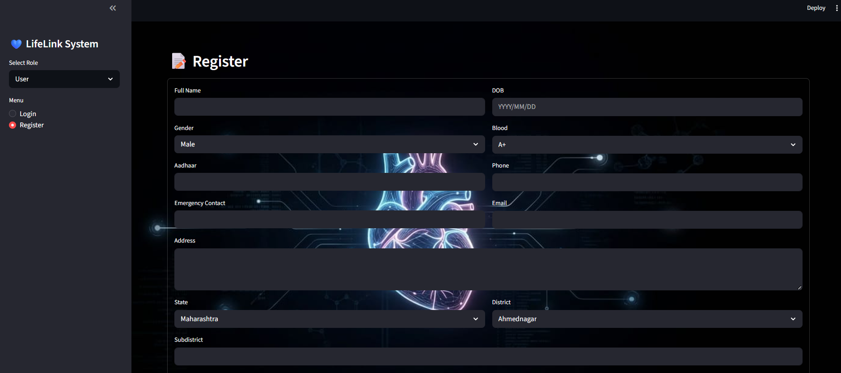
- Technologies Used
• Python
• Streamlit
• SQLite3
Database Connection
- Users Table:
Stores login details for normal users.
Fields Used:
• username
• password
- Hospitals Table:
Stores login details for hospitals.
- Fields Used:
• hospital_username
• hospital_password
- Organ Bank Table
Stores organ bank login information.
Fields Used:
• bank_username
• bank_password

- Admin Table
Stores administrator login credentials.
Fields Used:
• admin_username
• admin_password
- Data Storage Process
- During registration, the entered username and password are stored in the respective table.
- During login, the entered credentials are compared with stored database records.
- If records match, dashboard access is provided.
- If records do not match, login is rejected.

- Workflow
- User selects role.
- Username and password are entered.
- System validates empty fields.
- Database verification starts.
- Credentials are matched.
- Dashboard access is granted or error message is displayed.

2. Donor Registration Algorithm
Algorithm Information
The Donor Registration Algorithm is used only for donor registration functionality in the User Module. This functionality allows users to register themselves as organ donors digitally.
The user enters donor details such as blood group, contact number, address, and organ donation information. The system validates the entered details and stores them in the donor-related table.
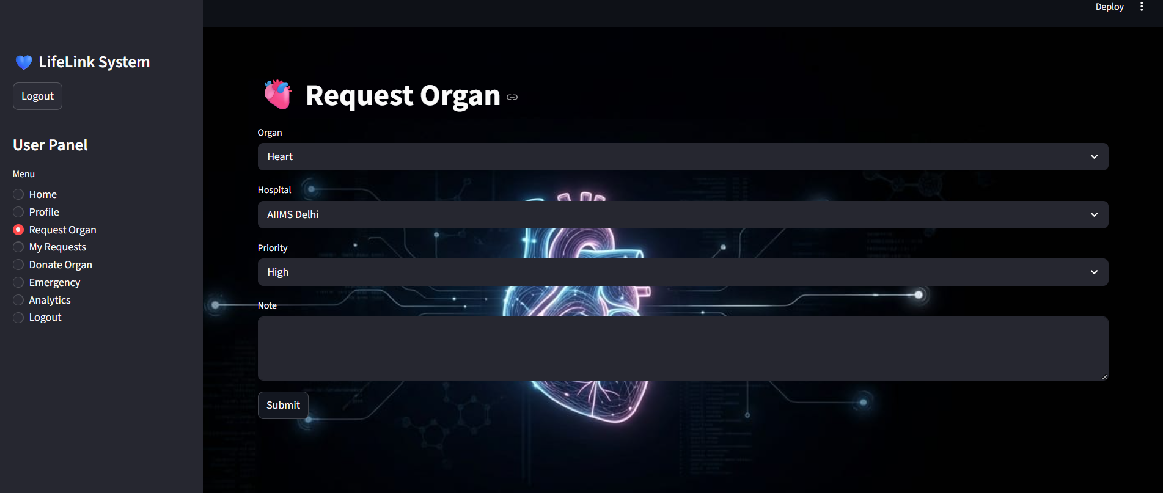

- Technologies Used
• Python
• Streamlit
• SQLite3
- Database Connection
Donor Table / Users Table
Fields Used:
• donor_name
• blood_group
• organ_name
• address
• contact_number
- Data Storage Process
- User enters donor details.
- System validates donor information.
- Python inserts donor records into database.
- Stored donor data becomes available for hospitals and organ banks during matching operations.
- Workflow
- Open donor registration form.
- Enter donor information.
- Validate fields.
- Store donor records.
3. Donor Matching Algorithm
Algorithm Information
The Donor Matching Algorithm is mainly connected with Hospital and Organ Bank modules. This functionality helps hospitals find suitable organ donors based on blood group compatibility.
Hospitals enter organ requirement details and recipient blood group. The system compares the recipient blood group with donor records stored in the database. Compatible donor records are displayed for emergency processing.
This functionality is connected only with donor search and emergency request handling.
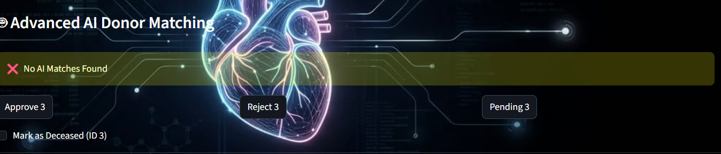

Technologies Used
• Python
• SQLite3
• Streamlit

Database Connection
Donor Table
Fields Used:
• donor_name
• blood_group
• organ_name
• availability_status
Emergency Request Table
Fields Used:
• recipient_blood_group
• required_organ

Data Storage Process
- Hospital enters recipient details.
- System searches donor records.
- Blood groups are compared.
- Matching donor records are displayed.

Workflow
- Enter recipient blood group.
- Search donor records.
- Match compatibility.
- Display matching donors.
4. Emergency Request Algorithm
Algorithm Information
The Emergency Request Algorithm is connected mainly with Hospitals and Organ Banks. Hospitals use this functionality to send emergency organ requests quickly.
The hospital enters organ requirement details, blood group information, and patient details. The request is stored in the Emergency Request Table. Organ banks can view and process these requests according to organ availability.
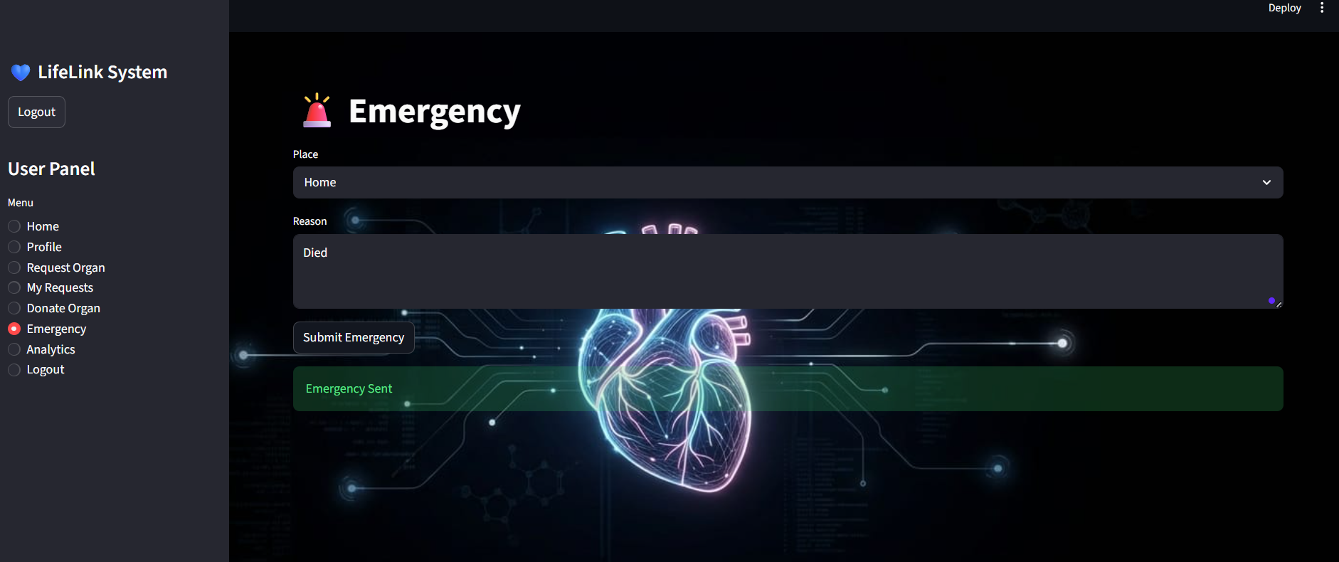

- Technologies Used
• Python
• Streamlit
• SQLite3
- Database Connection
Emergency Request Table
Fields Used:
• request_id
• hospital_name
• organ_required
• blood_group
• request_status
Data Storage Process
- Hospital submits request.
- Request details are stored in Emergency Request Table.
- Organ banks access request records.
- Request status gets updated during processing.
- Workflow
- Hospital creates request.
- Request is validated.
- Data is stored.
- Organ bank processes request.
- Status is updated.
5. Inventory Management Algorithm
Algorithm Information
The Inventory Management Algorithm is connected mainly with Organ Banks and Admin Module. Organ banks maintain organ availability records through this functionality.
Organ details such as organ name, quantity, donor details, and availability status are entered and updated regularly. Admin can monitor inventory information through dashboards.
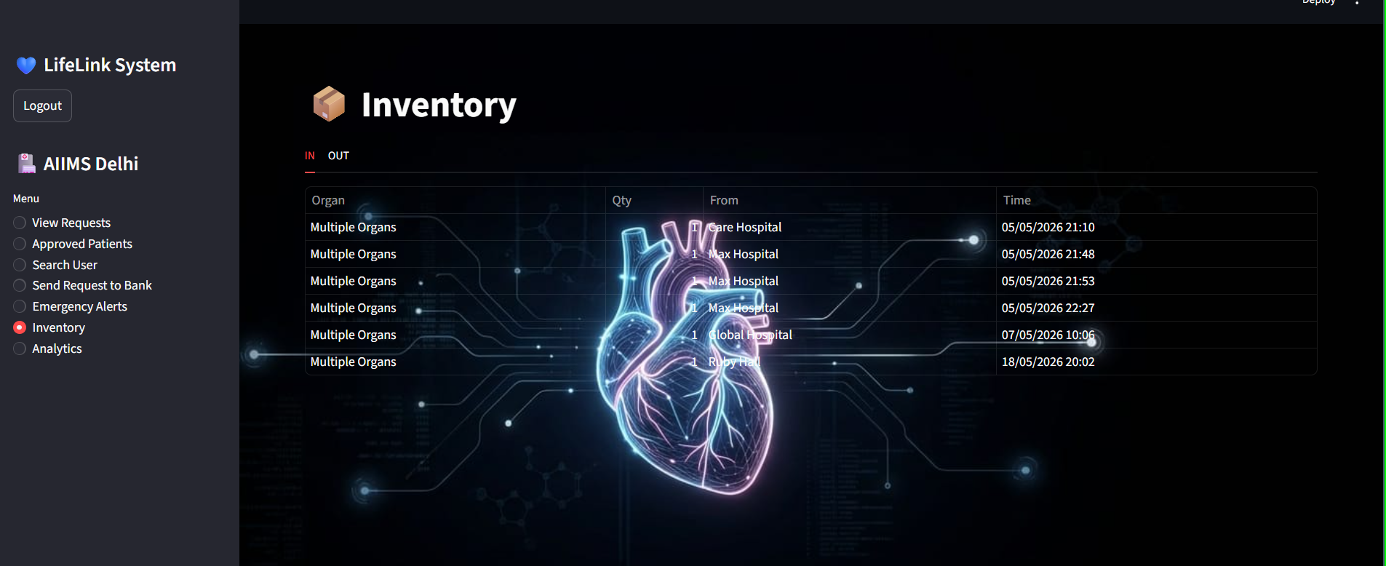

Technologies Used
• Python
• Streamlit
• SQLite3
Database Connection
Inventory Table
Fields Used:
• organ_name
• quantity
• donor_details
• availability_status
Data Storage Process
- Organ bank enters inventory details.
- System validates information.
- Inventory records are inserted or updated.
- Updated inventory becomes visible to hospitals and admin.
Workflow
- Open inventory section.
- Add or update organ details.
- Validate information.
- Store inventory data.
- Display updated inventory.

6. Analytics Dashboard Algorithm
Algorithm Information
The Analytics Dashboard Algorithm is connected only with the Admin Module. This functionality is used for monitoring healthcare activities, donor registrations, inventory records, and emergency request statistics.
The system collects stored data and generates graphical reports and analytics charts for administrators.
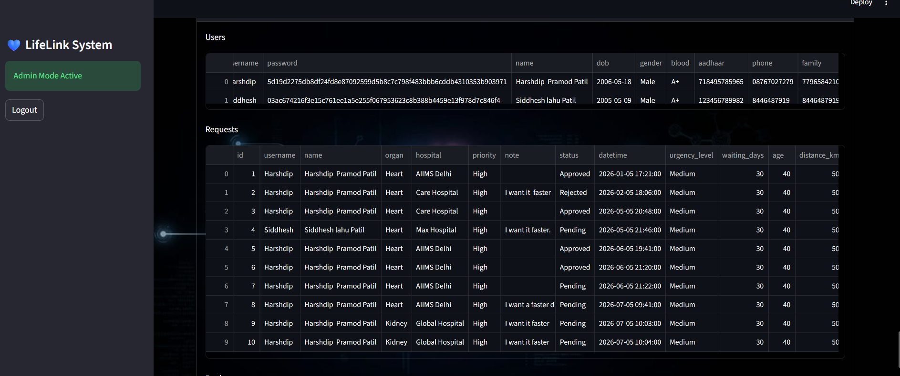

Technologies Used
• Python
• Pandas
• Matplotlib
• Streamlit

Database Connection
Tables Used
• Users Table
• Inventory Table
• Emergency Request Table

Data Storage Process
- System collects healthcare records from database tables.
- Analytics data is processed using Python.
- Charts and reports are generated dynamically.
- Dashboard displays monitoring information.

Workflow
- Collect healthcare data.
- Process analytics information.
- Generate reports and charts.
- Display analytics dashboard.

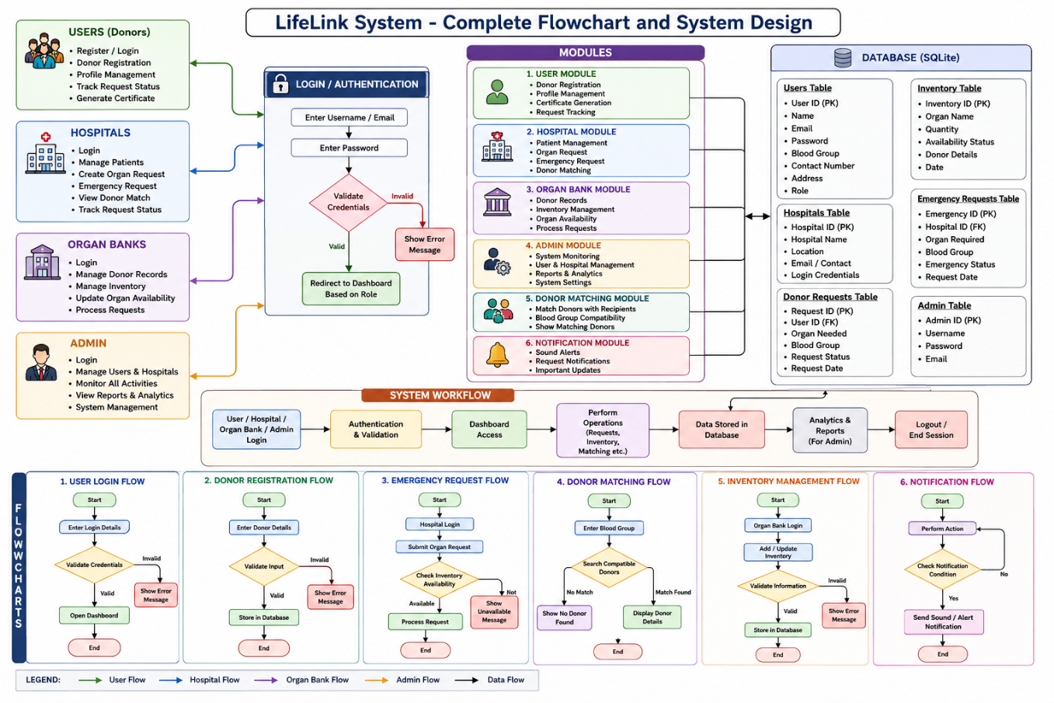
5.2 Flowcharts

Chapter 6 :Testing

6.1 Input Validation
The Life+Link System performs input validation to ensure secure and accurate data entry throughout the healthcare management process. During registration, the system verifies whether all required fields are entered properly. Duplicate email or username registration is restricted to prevent multiple accounts with the same credentials.
During login, the system validates usernames, emails, and passwords with database records and displays appropriate error messages for invalid login attempts. In the donor registration module, the system validates blood group details, contact information, and organ donation preferences before storing records in the database.
The emergency request module validates hospital details, organ request information, and blood group data before processing emergency requests. The donor matching module checks blood group compatibility before displaying matching donor records.
The inventory management module validates organ quantity, availability status, and donor details before updating database records. The certificate generation functionality also verifies donor information before generating digital certificates.
Input validation improves system security, reliability, database integrity, and healthcare record accuracy by preventing invalid, incomplete, or incorrect data from being stored in the system.

Chapter 7 : Conclusion

The Life+Link System successfully provides a simple, secure, and efficient web-based healthcare and organ donation management platform. The project helps users register as organ donors, manage donor details, and access healthcare services through a centralized digital system.
The platform also helps hospitals manage patient records, emergency organ requests, and donor matching operations efficiently. Organ banks can maintain donor inventory, process requests, and monitor organ availability through the system. The administrator module provides analytics dashboards and monitoring features for better healthcare management and reporting.
The use of Python, Streamlit, and SQLite3 provides secure database management, smooth system functionality, and interactive user interface support. The project reduces manual paperwork and improves communication between users, hospitals, and organ banks through digital automation.
The donor matching functionality based on blood group compatibility improves emergency healthcare response and simplifies organ request processing. The organized database structure and responsive interface improve overall system performance, usability, and reliability.
Future improvements may include cloud database integration, mobile application support, SMS and email notifications, real-time hospital tracking, and advanced AI-based donor prediction systems. Overall, the Life+Link System fulfills its objective of providing a user-friendly, reliable, and centralized healthcare and organ donation management platform.

References

a) Journal/Conference Papers
- Research Papers on Healthcare Management Systems
- Organ Donation and Transplantation Management Research Articles
- Healthcare Analytics and Emergency Response System Journals
- Research Papers on Web-Based Healthcare Applications
- Digital Healthcare Communication System Research Papers

b) Book References
- Python Programming by Reema Thareja
- Database System Concepts by Abraham Silberschatz
- Software Engineering by Roger Pressman
- Fundamentals of Database Systems by Elmasri and Navathe
- Web Technologies by Uttam K. Ro

c) Web References
- Python Official Documentation:
https://docs.python.org/3/
Used for Python programming concepts, Streamlit integration, database handling, and backend development.

- Streamlit Official Documentation:
sqlite3 — DB-API 2.0 interface for SQLite databases — Python 3.14.5 documentation
Reference for Streamlit components, dashboard creation, forms, session handling, and web application development.

- SQLite3 Documentation:
https://docs.python.org/3/library/sqlite3.html
Used for database creation, SQL queries, and database operations.

- SQLite Official Website:
https://www.sqlite.org/
Reference for relational database concepts and SQLite database management.

- W3Schools:
https://www.w3schools.com/
Used for frontend concepts, Python basics, forms, and interface design references.

- Visual Studio Code Documentation:
https://code.visualstudio.com/docs
Used for project development environment and code management.

